**Project Proposal- Project 3**

**Group Members: George Pasley, Basanta, Chloe Collins, Jonathan Richards, Godfrey Edokpia, Anna Phimmasone**

Topic and Rationale: A continuation of Charlotte tourism analysis, now incorporating restaurants and local business. We will be updating our previous ETL project by conducting mapping via Leaflet and D3. Our final product will be a holistic Charlotte Tourism website.

Dataset(s):

* data.charlottenc.gov
* <https://github.com/aphimma3/group4project3/blob/master/lynx.csv>
* <https://raw.githubusercontent.com/aphimma3/group4project3/master/new_yelp.csv>
* <https://github.com/aphimma3/group4project3/blob/master/top_rated_restaurants.csv>

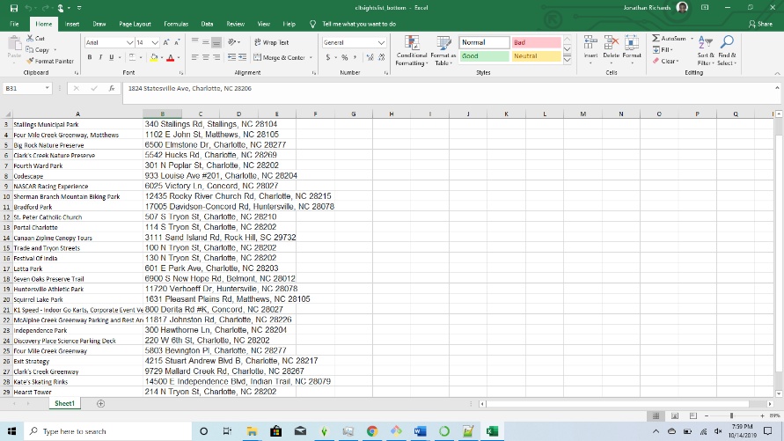Github repository: [https://github.com/aphimma3 /group4project3](https://github.com/aphimma3/group4project3)